**Name:- Milind Kailas Tajane**

**Roll No:- CS061**

**Date:-____________**

**Practical No:1**

# ----------------------------------------------------------------

**AIM:- Write a java program to create a person class with the attribute name and age. Create instances and their attributes using constructor and print their name and age.**

**---------------------------------------------------------------------------------------------------------------**

**CODE:-**

class Main {

String name;

int age;

// Constructor to initialize name and age

public Main(String name, int age) {

this.name = name;

this.age = age;

}

// Method to display details

public void display() {

System.out.println("Name: " + name );

System.out.println("Age: " + age);

}

public static void main(String[] args) {

// Creating instances of Person

Main person = new Main("Milind", 22);

// Displaying details

person.display();

}

}

**Output:-**

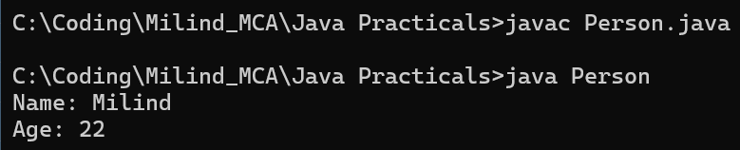

**Name:- Milind Kailas Tajane**

**Roll No:- CS061**

**Date:-____________**

**Practical No:2**

# ----------------------------------------------------------------

**AIM:- Write a java program to create circle with radius attribute , you can access and modify the attributes and calculate area and circumference of circle.**

**----------------------------------------------------------------------------------------------------------------**

**CODE:-**

class Circle {

    double radius;

    // Constructor to initialize radius

    public Circle(double radius) {

        this.radius = radius;

    }

    // Getter method for radius

    public double getRadius() {

        return radius;

    }

    // Setter method for radius

    public void setRadius(double radius) {

        this.radius = radius;

    }

    // Method to calculate area

    public double calculateArea() {

        return Math.PI * radius * radius;

    }

    // Method to calculate circumference

    public double calculateCircumference() {

        return 2 * Math.PI * radius;

    }

    public static void main(String[] args) {

        // Creating an instance of Circle

        Circle circle = new Circle(5.0);

        // Displaying details

        System.out.println("Radius: " + circle.getRadius());

        System.out.println("Area: " + circle.calculateArea());

        System.out.println("Circumference: " + circle.calculateCircumference());

        // Modifying radius

        circle.setRadius(7.0);

        System.out.println("\nAfter modifying radius:");

        System.out.println("Radius: " + circle.getRadius());

        System.out.println("Area: " + circle.calculateArea());

        System.out.println("Circumference: " + circle.calculateCircumference());

    }

}

**Output:-**

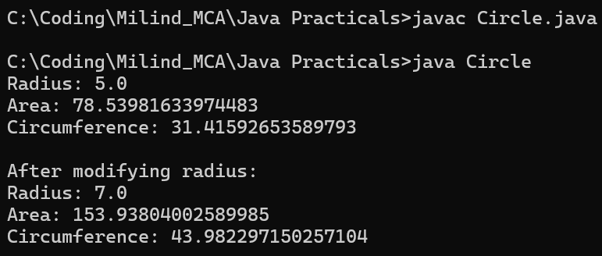

**Name:- Milind Kailas Tajane**

**Roll No:- CS061**

**Date:-____________**

**Practical No: 3**

# ----------------------------------------------------------------

**AIM:- Write a java program to create library with the collection of books and methods two add or remove books.**

**----------------------------------------------------------------------------------------------------------------**

**CODE:-**

import java.util.ArrayList;

class Library {

    private ArrayList<String> books;

    public Library() { books = new ArrayList<>(); }

    public void addBook(String book) { books.add(book); }

    public void removeBook(String book) { books.remove(book); }

    public void displayBooks() {

        System.out.println("Books in library: " + books);

    }

    public static void main(String[] args) {

        Library library = new Library();

        library.addBook("The Great Gatsby");

        library.addBook("1984");

        library.displayBooks();

        library.removeBook("1984");

        library.displayBooks();

    }

}

**Output:-**

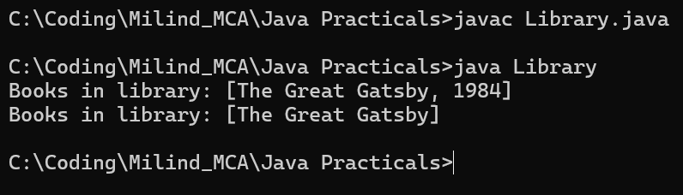

**Name:- Milind Kailas Tajane**

**Roll No:- CS061**

**Date:-____________**

**Practical No: 4**

# ----------------------------------------------------------------

**AIM:- Write a java program convert the rupees amount to words.**

**----------------------------------------------------------------------------------------------------------------**

**CODE:-**

import java.text.DecimalFormat;

class NumberToWords {

    private static final String[] units = {"", "One", "Two", "Three", "Four", "Five", "Six", "Seven", "Eight", "Nine", "Ten", "Eleven", "Twelve", "Thirteen", "Fourteen", "Fifteen", "Sixteen", "Seventeen", "Eighteen", "Nineteen"};

    private static final String[] tens = {"", "", "Twenty", "Thirty", "Forty", "Fifty", "Sixty", "Seventy", "Eighty", "Ninety"};

    public static String convert(int number) {

        if (number == 0) return "Zero";

        return convertNumberToWords(number);

    }

    private static String convertNumberToWords(int number) {

        if (number < 20) return units[number];

        if (number < 100) return tens[number / 10] + (number % 10 != 0 ? " " + units[number % 10] : "");

        if (number < 1000) return units[number / 100] + " Hundred" + (number % 100 != 0 ? " " + convertNumberToWords(number % 100) : "");

        if (number < 100000) return convertNumberToWords(number / 1000) + " Thousand" + (number % 1000 != 0 ? " " + convertNumberToWords(number % 1000) : "");

        if (number < 10000000) return convertNumberToWords(number / 100000) + " Lakh" + (number % 100000 != 0 ? " " + convertNumberToWords(number % 100000) : "");

        return convertNumberToWords(number / 10000000) + " Crore" + (number % 10000000 != 0 ? " " + convertNumberToWords(number % 10000000) : "");

    }

    public static void main(String[] args) {

        int amount = 230020;

        System.out.println("Rupees " + new DecimalFormat("#,##0").format(amount) + " in words: " + convert(amount) + " Rupees");

    }

}

**Output:-**

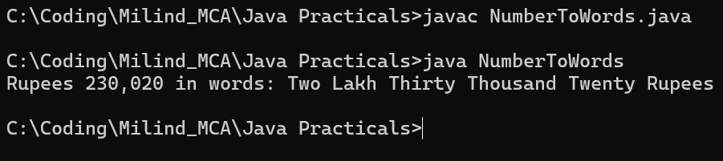

**Name:- Milind Kailas Tajane**

**Roll No:- CS061**

**Date:-____________**

**Practical No: 5**

# ----------------------------------------------------------------

**AIM:- Write a java program to convert Celsius to Fahrenheit and vice versa.**

**----------------------------------------------------------------------------------------------------------------**

**CODE:-**

import java.util.Scanner;

class TemperatureConverter {

    public static double celsiusToFahrenheit(double celsius) {

        return (celsius * 9/5) + 32;

    }

    public static double fahrenheitToCelsius(double fahrenheit) {

        return (fahrenheit - 32) * 5/9;

    }

    public static void main(String[] args) {

        Scanner scanner = new Scanner(System.in);

        System.out.print("Enter temperature: ");

        double temperature = scanner.nextDouble();

        System.out.print("Convert to (C/F): ");

        char choice = scanner.next().charAt(0);

        if (choice == 'C' || choice == 'c') {

            System.out.println("Temperature in Celsius: " + fahrenheitToCelsius(temperature));

        } else if (choice == 'F' || choice == 'f') {

            System.out.println("Temperature in Fahrenheit: " + celsiusToFahrenheit(temperature));

        } else {

            System.out.println("Invalid choice");

        }

        scanner.close();

    }

}

**Output:-**

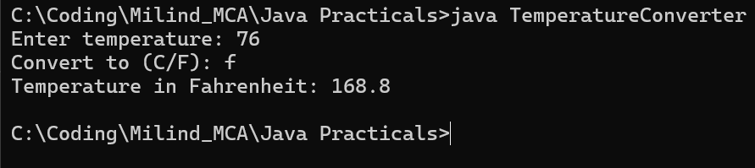

**Name:- Milind Kailas Tajane**

**Roll No:- CS061**

**Date:-____________**

**Practical No: 6**

# ----------------------------------------------------------------

**AIM:- Write a java program to print the sum of given number.**

**----------------------------------------------------------------------------------------------------------------**

**CODE:-**

import java.util.Scanner;

class SumCalculator {

    public static int calculateSum(int number) {

        int sum = 0;

        while (number != 0) {

            sum += number % 10;

            number /= 10;

        }

        return sum;

    }

    public static void main(String[] args) {

        Scanner scanner = new Scanner(System.in);

        System.out.print("Enter a number: ");

        int number = scanner.nextInt();

        System.out.println("Sum of digits: " + calculateSum(number));

        scanner.close();

    }

}

**Output:-**

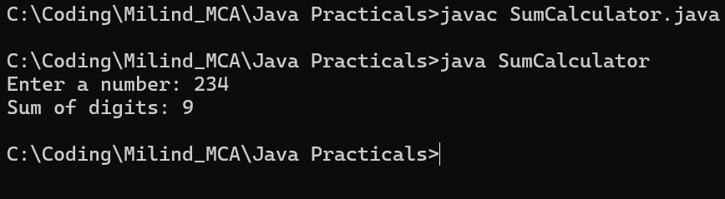

**Name:- Milind Kailas Tajane**

**Roll No:- CS061**

**Date:-____________**

**Practical No: 7**

# ----------------------------------------------------------------

**AIM:- Write a java program to perform all the arithmetic operator.**

**----------------------------------------------------------------------------------------------------------------**

**CODE:-**

import java.util.Scanner;

class ArithmeticOperations {

    public static void main(String[] args) {

        Scanner scanner = new Scanner(System.in);

        System.out.print("Enter first number: ");

        double num1 = scanner.nextDouble();

        System.out.print("Enter second number: ");

        double num2 = scanner.nextDouble();

        System.out.println("Addition: " + (num1 + num2));

        System.out.println("Subtraction: " + (num1 - num2));

        System.out.println("Multiplication: " + (num1 * num2));

        System.out.println("Division: " + (num1 / num2));

        System.out.println("Modulus: " + (num1 % num2));

        scanner.close();

    }

}

**Output:-**

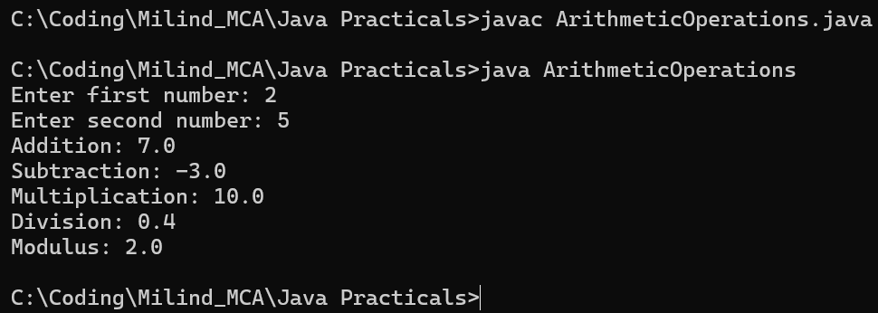

**Name:- Milind Kailas Tajane**

**Roll No:- CS061**

**Date:-____________**

**Practical No: 8**

# ----------------------------------------------------------------

**AIM:- .Write a java program to perform bitwise operator.**

**----------------------------------------------------------------------------------------------------------------**

**CODE:-**

import java.util.Scanner;

class BitwiseOperations {

    public static void main(String[] args) {

        Scanner scanner = new Scanner(System.in);

        System.out.print("Enter first integer: ");

        int num1 = scanner.nextInt();

        System.out.print("Enter second integer: ");

        int num2 = scanner.nextInt();

        System.out.println("Bitwise AND: " + (num1 & num2));

        System.out.println("Bitwise OR: " + (num1 | num2));

        System.out.println("Bitwise XOR: " + (num1 ^ num2));

        System.out.println("Bitwise Complement of first number: " + (~num1));

        System.out.println("Left Shift (num1 << 2): " + (num1 << 2));

        System.out.println("Right Shift (num1 >> 2): " + (num1 >> 2));

        scanner.close();

    }

}

**Output:-**

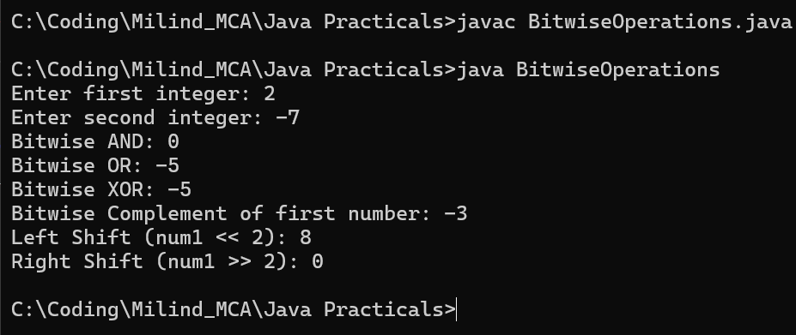

**Name:- Milind Kailas Tajane**

**Roll No:- CS061**

**Date:-____________**

**Practical No: 9**

# ----------------------------------------------------------------

**AIM:- Write a java program to check leap year.**

**----------------------------------------------------------------------------------------------------------------**

**CODE:-**

import java.util.Scanner;

class LeapYearChecker {

    public static void main(String[] args) {

        Scanner scanner = new Scanner(System.in);

        System.out.print("Enter a year: ");

        int year = scanner.nextInt();

        if ((year % 4 == 0 && year % 100 != 0) || (year % 400 == 0)) {

            System.out.println(year + " is a Leap Year.");

        } else {

            System.out.println(year + " is not a Leap Year.");

        }

        scanner.close();

    }

}

**Output:-**

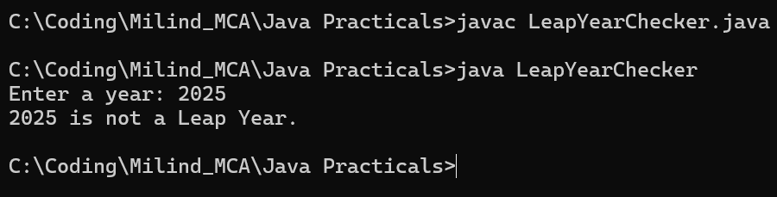

**Name:- Milind Kailas Tajane**

**Roll No:- CS061**

**Date:-____________**

**Practical No: 10**

# ----------------------------------------------------------------

**AIM:- .Write a java program to Convert decimal to binary, octal, hex.**

**----------------------------------------------------------------------------------------------------------------**

**CODE:-**

import java.util.Scanner;

class NumberConverter {

    public static void main(String[] args) {

        Scanner scanner = new Scanner(System.in);

        System.out.print("Enter a decimal number: ");

        int decimal = scanner.nextInt();

        System.out.println("Binary: " + Integer.toBinaryString(decimal));

        System.out.println("Octal: " + Integer.toOctalString(decimal));

        System.out.println("Hexadecimal: " + Integer.toHexString(decimal).toUpperCase());

        scanner.close();

    }

}

**Output:-**

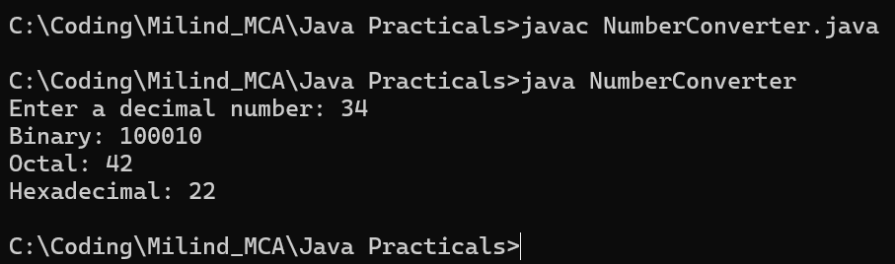

**Name:- Milind Kailas Tajane**

**Roll No:- CS061**

**Date:-____________**

**Practical No: 11**

# ----------------------------------------------------------------

**AIM:- Write a java program to Print prime numbers 1 to 100.**

**----------------------------------------------------------------------------------------------------------------**

**CODE:-**

class PrimeNumbers {

    public static void main(String[] args) {

        System.out.println("Prime numbers from 1 to 100:");

        for (int num = 2; num <= 100; num++) {

            if (isPrime(num)) {

                System.out.print(num + " ");

            }

        }

    }

    public static boolean isPrime(int n) {

        if (n < 2) return false;

        for (int i = 2; i <= Math.sqrt(n); i++) {

            if (n % i == 0) return false;

        }

        return true;

    }

}

**Output:-**

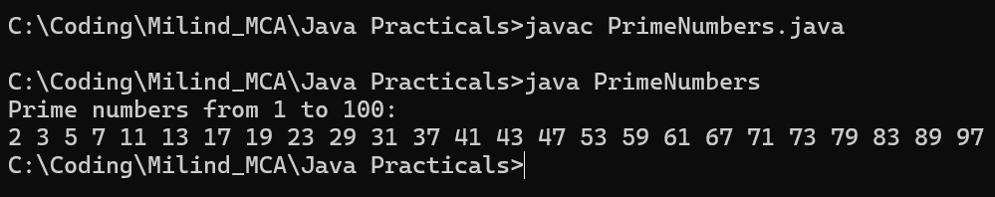

**Name:- Milind Kailas Tajane**

**Roll No:- CS061**

**Date:-____________**

**Practical No: 12**

# ----------------------------------------------------------------

**AIM:- Write a java program to print Factorial of a number.**

**----------------------------------------------------------------------------------------------------------------**

**CODE:-**

import java.util.Scanner;

class Factorial {

    public static void main(String[] args) {

        Scanner scanner = new Scanner(System.in);

        System.out.print("Enter a number: ");

        int num = scanner.nextInt();

        System.out.println("Factorial of " + num + " is: " + factorial(num));

        scanner.close();

    }

    public static long factorial(int n) {

        long fact = 1;

        for (int i = 1; i <= n; i++) {

            fact *= i;

        }

        return fact;

    }

}

**Output:-**

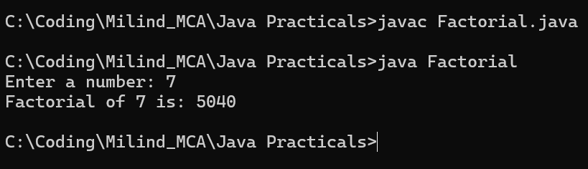

**Name:- Milind Kailas Tajane**

**Roll No:- CS061**

**Date:-____________**

**Practical No: 13**

# ----------------------------------------------------------------

**AIM:- Write a java program to print the pattern.**

**----------------------------------------------------------------------------------------------------------------**

**CODE:-**

import java.util.Scanner;

class PatternPrinter {

    public static void main(String[] args) {

        Scanner scanner = new Scanner(System.in);

        System.out.print("Enter the number of rows: ");

        int rows = scanner.nextInt();

        for (int i = 1; i <= rows; i++) {

            for (int j = 1; j <= i; j++) {

                System.out.print("* ");

            }

            System.out.println();

        }

        scanner.close();

    }

}

**Output:-**

